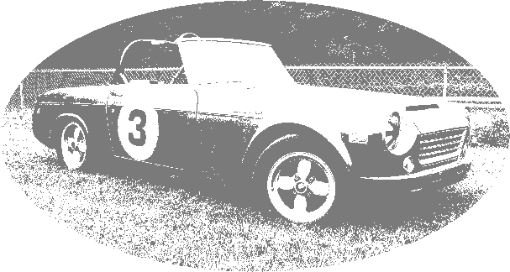
The owner of this certificate has passed beginner's training and is hereby decreed an official honorary member of the NoName Racing Pit Crew.
The owner of this certificate has passed beginner's training and is hereby decreed an official honorary member of the NoName Racing Pit Crew.

